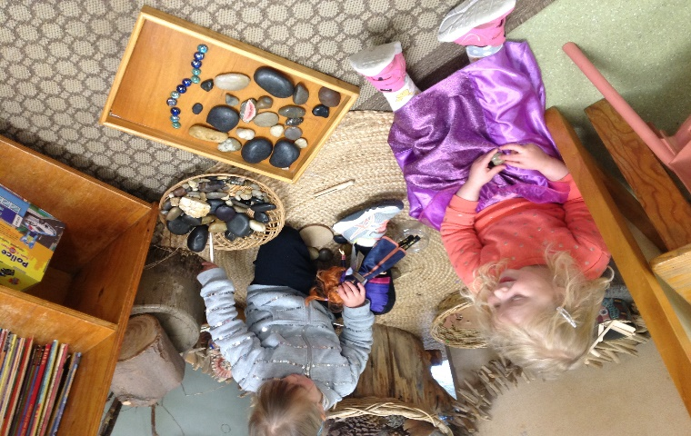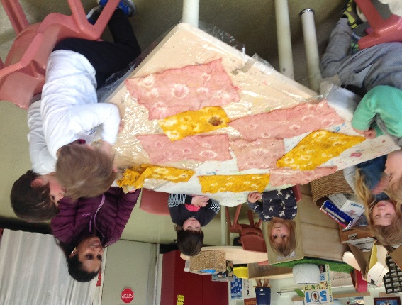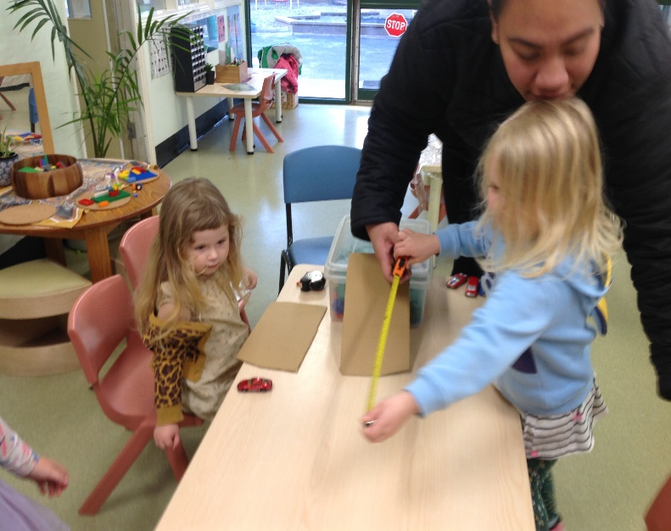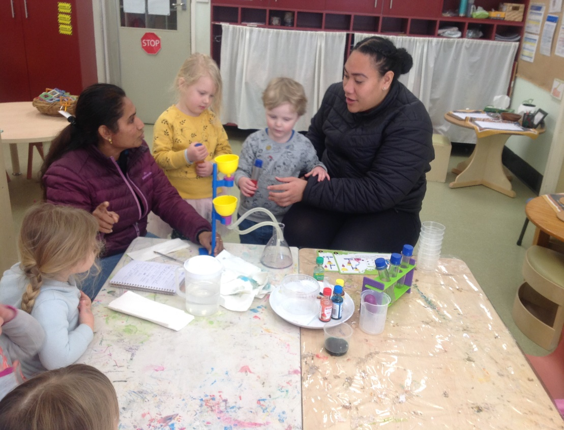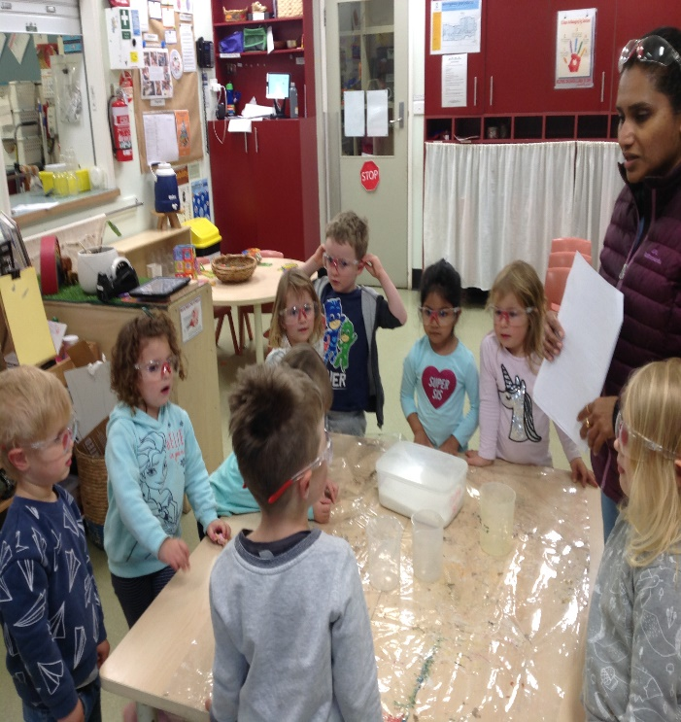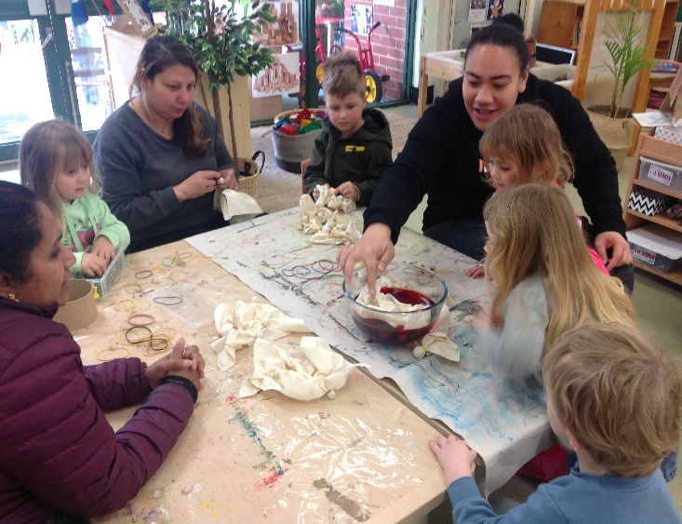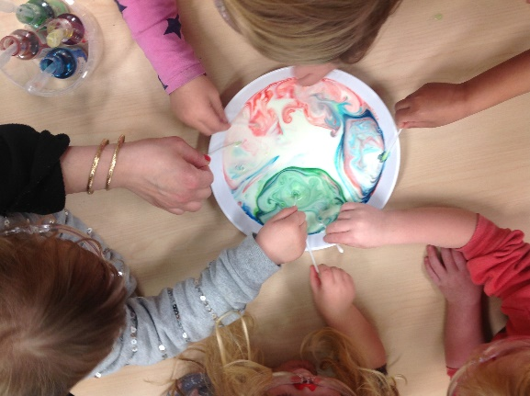**Reflection 2, August 2020, Kookaburra Room.**

The second half of August has been very busy with Science week activities galore. The Koalas participated in Swirling Galaxy experiment featuring chemical reactions. Milk, food colouring and soap were carefully mixed together causing movement from separating particles to create a swirling colourful magical galaxy right before our eyes! The Koalas also explored floating and sinking objects with salted water and we made some flying objects too. Nanisi experimented with ramps, objects and friction. This moved onto measuring distance travelled by vehicles and the children experienced working with number and data. (mathematics). We planted some strawberries outside for spring as part of our ongoing sustainability and garden project. One of the beetroots we grew in the community garden was used to extract juice for dye. The children made tie dyed cloths using the beetroot juice and also turmeric to make yellow dye. The children sewed the cloth together, with help, and the result was a lovely wall art display. It is on display in the Kookaburra room so come and take a look! The children also enjoyed exploring natural items creating patterns, shapes and expressing themselves with loose parts. Another experiment was colour mixing. A funnel set up and tubes were used to mix colours together. Hypothesis’ were gathered and many children showed they have a good knowledge of primary and secondary colour. This was great news as we have previously provided many experiences with colour blending. We are now looking forward to our friends returning soon If restrictions change and some milder days of Spring in Melbourne!!

**Links to the National Quality Standards: Quality area 1 Educational program and practice and TRCC Philosophy**