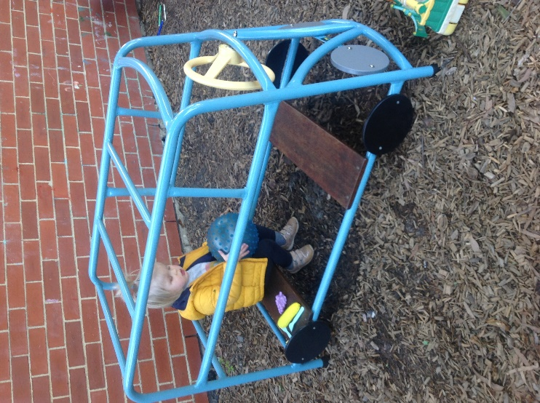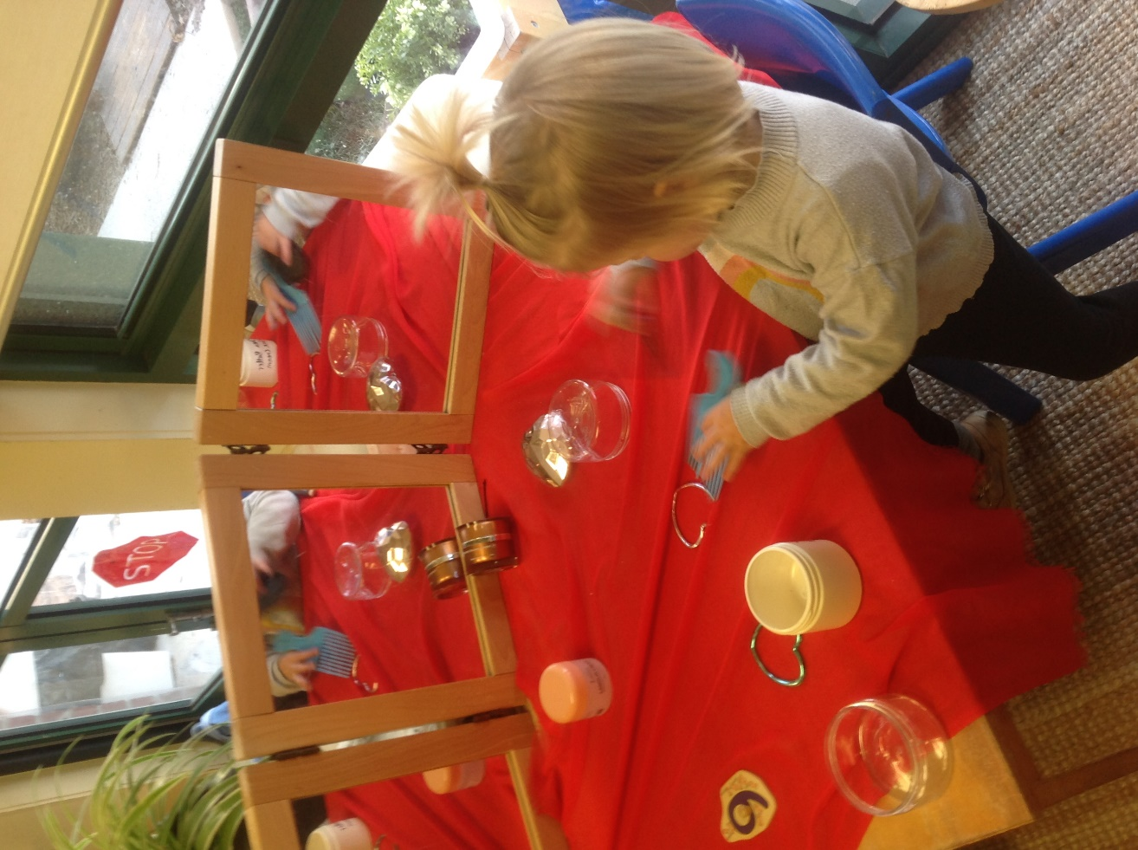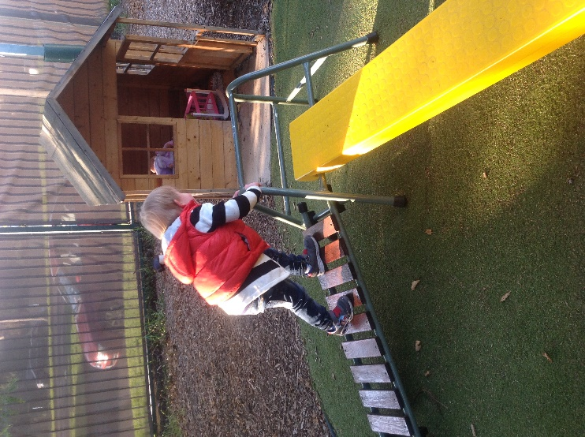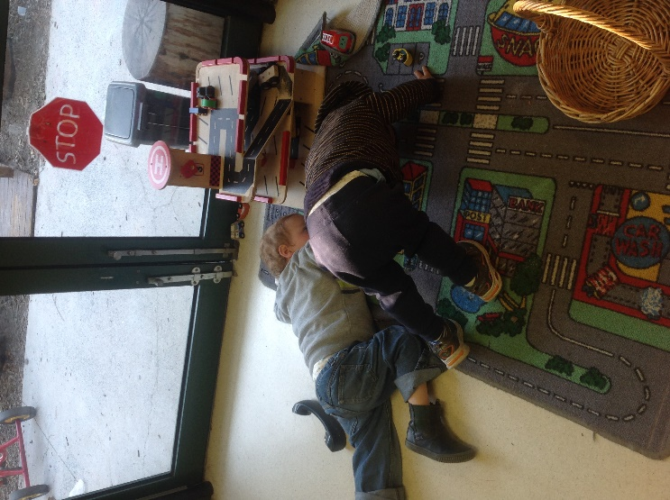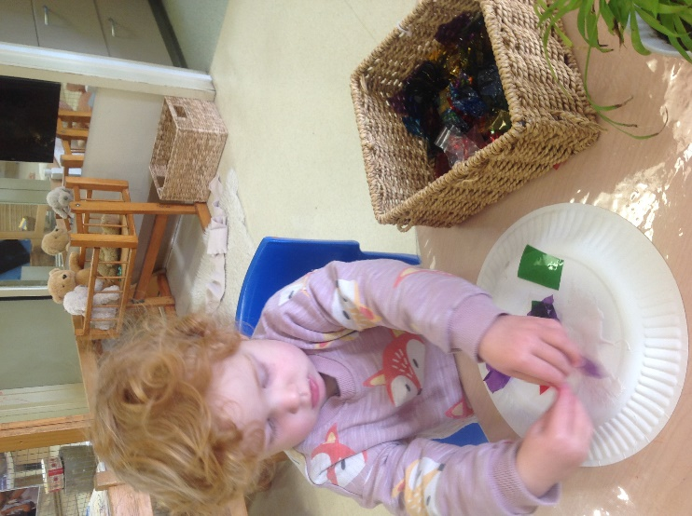

June Reflection 2020

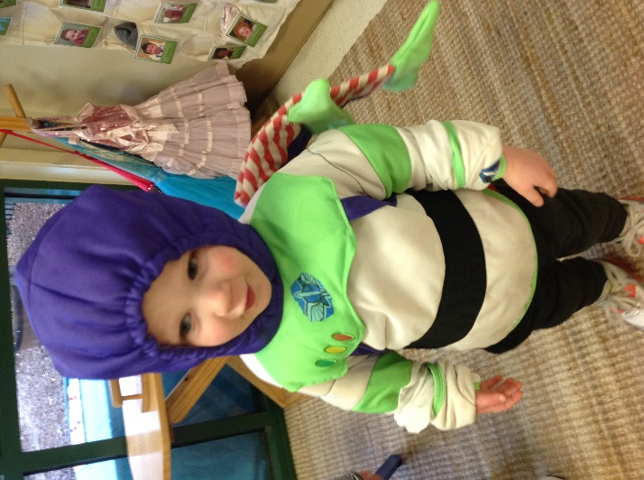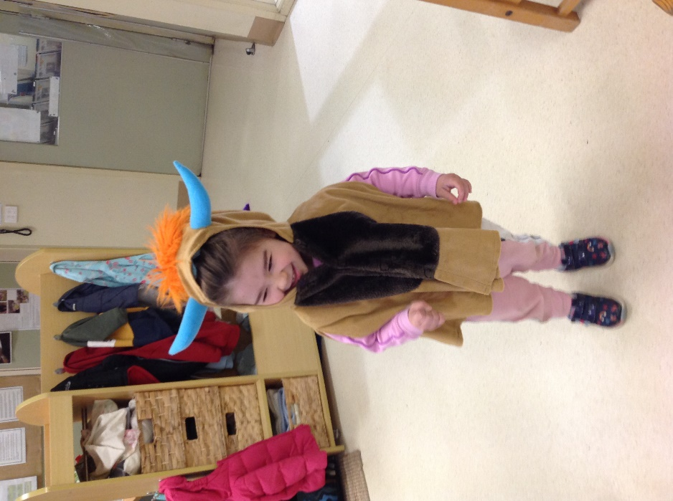

June has brought us some interesting weather. One day it is sunny and warm and the next it is raining and very cold. On the really cold days, educators are noticing that this weather is not affecting where the children want to play. What is affecting our interest is the new things placed out for the month.

This month, the educators set up a few experiences that the children are very excited about. Our biggest area of interest is our dress up area. Educators placed out a dress up table with many types of pampering products which the children are eager to create their own imaginative play opportunities. This area also houses dress ups and costumes for the children to use.

Another area showing a lot of interest is the teddy bear hospital. This is the first opportunity to have play experiences using electronics such as keyboard and phones as well as doctor’s tools like a stethoscope and thermometer. Our Possums are good little nurses and doctors to our teddy bears.

In keeping with June’s environmental events (The start of winter, World Environment Day, World Ocean Day, etc.), the children have been creating an ocean of art. Each week in June the children helped to decide what ocean animal they would like to create using their favourite art mediums. The first week we created jellyfish by using cellophane and crepe paper on paper plates. This week the children are creating rainbow fish, our newest literary interest. This works of art are being hung from the ceiling to create a hanging ocean for us to explore.

Our group time has consisted of more ‘Very Hungry Caterpillar’ with ‘Rainbow Fish’ and other stories and songs about animals and insects. The small caterpillar books have been carried by every child around the room. Not only to be read but to explore placing the 4-book collection back into its original box. A great way to develop language, interest in reading and literacy, critical thinking and small motor development - all in one compact activity.

Another great area of interest is the community area. The introduction of a parking garage and cars has many of the children driving all over the room (impromptu yoga sessions during car play is always in style), with sounds of beeping and honking coming from everywhere.

Our outdoor area has changed a bit with new experiences and activities moved around for a fresh space to explore. The children are always driving in the a-frame cars, going to the zoo or the shops. The climbing equipment has been reconfigured and educators are seeing a lot more confidence and stability within their use. The children are now exploring the trees in our side yard and we are noticing more climbing attempts.

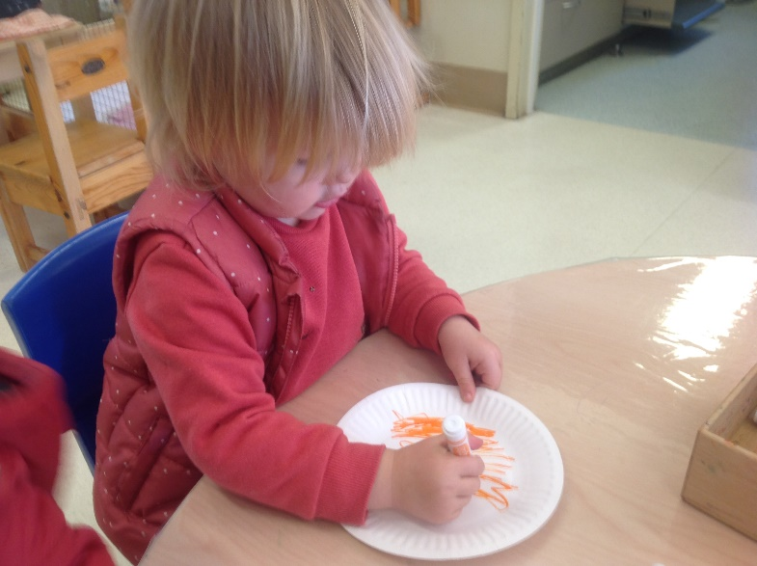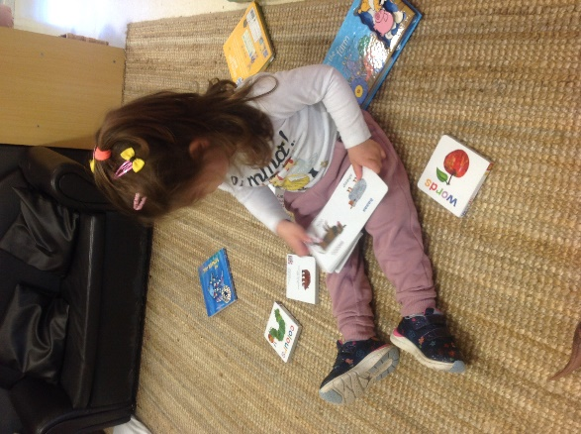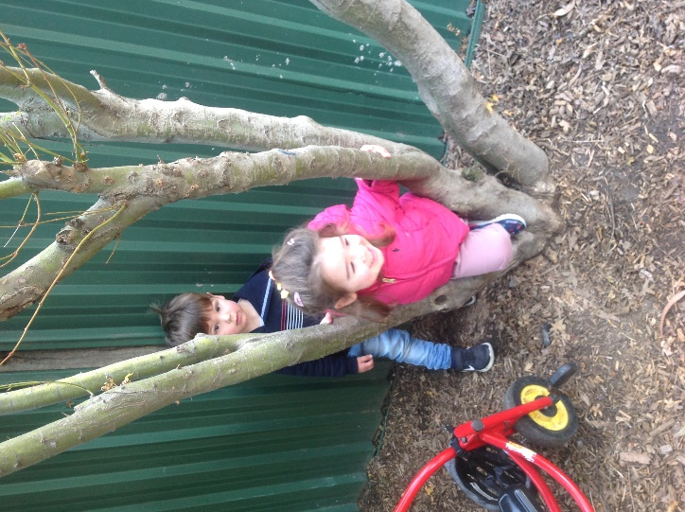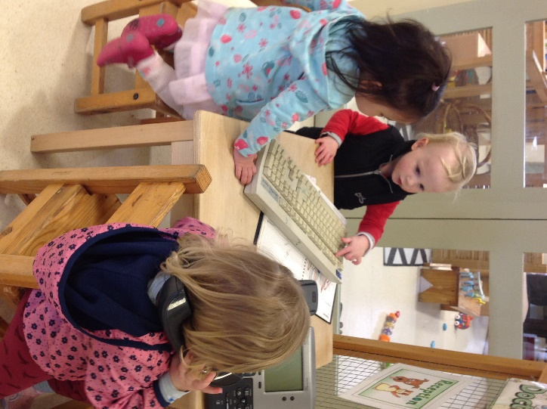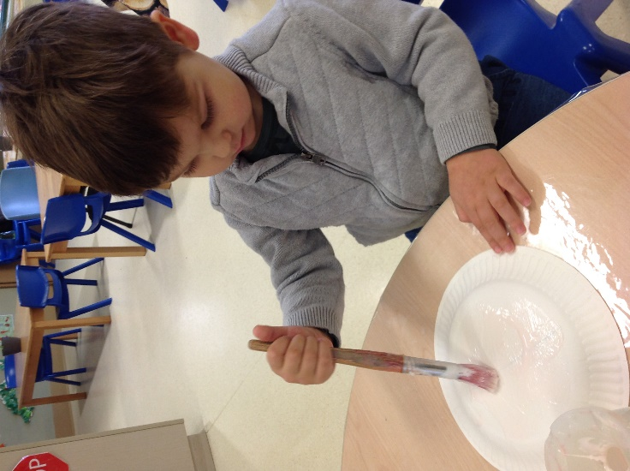

Well done Possum Room. Your educators are looking forward to seeing what the rest of the month has in store for us.

***Links to the National Quality Standards: Quality Area 1, Educational Program and Practice and the TRCC Philosophy***