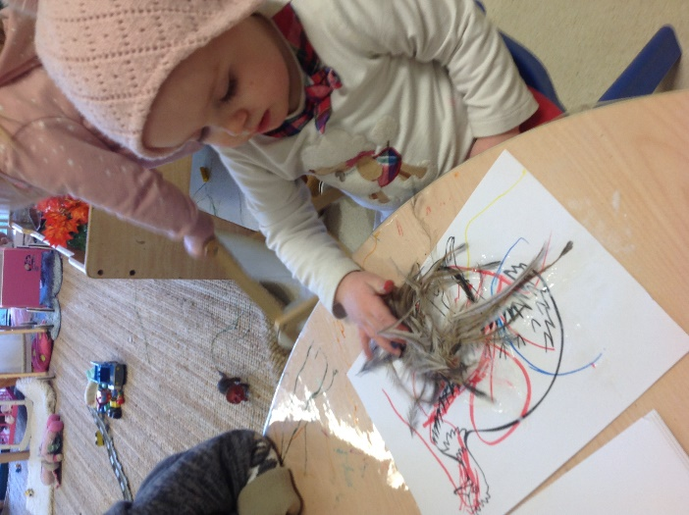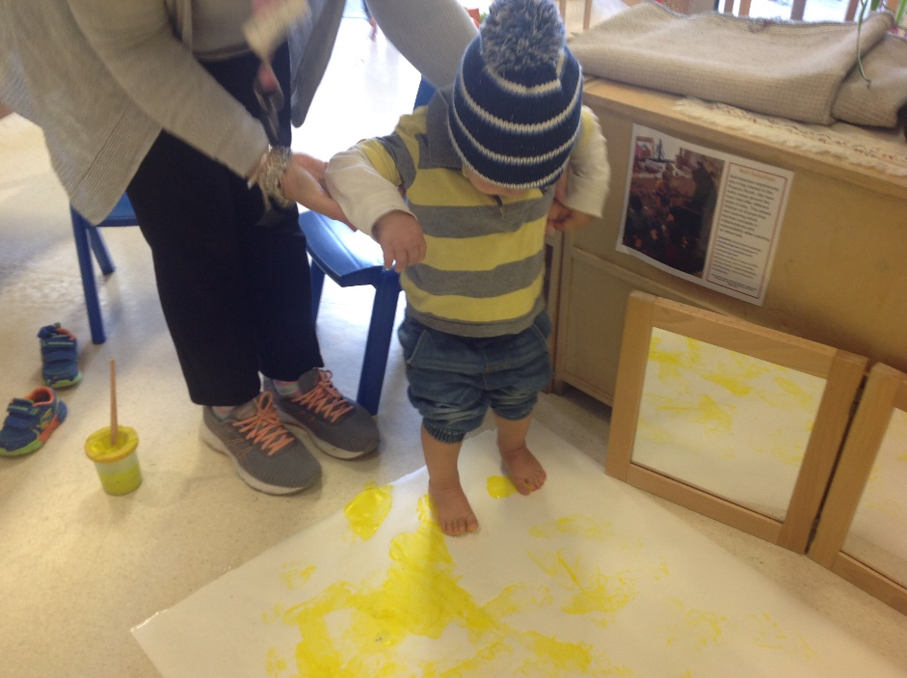

As May comes to a close, the Possum room has been a buzz with activity as we prepared this month’s S.T.E.M. project and we celebrated National Sorry Day and Reconciliation Week.

This month’s S.T.E.M. was to prepare and plant our veggie patch. This was done earlier in the month but the care of our lovely garden has continued throughout the month. We have also been focused on keeping the rest of our garden space heathy and watered to our plants can grow big and strong. We have now planted winter vegetable selection of lettuce, spinach, celery and silver beet and the children visit the herb and veggie patch daily to check on their progress.

Over the month of May, the children have begun a huge interest in the Very Hungry Caterpillar. Each day, the children have requested us to either watch a reading of this story using the iPad or have requested the book be read during our group time sessions. This interest had educators thinking about how we could incorporate this interest into other areas of play. Lena worked on creating the fruit and caterpillar out of cardboard for the children to decorate and then made a butterfly out of contact paper. These activities allowed the children to explore using paint and crepe paper to create textured artwork while the butterfly was used with small bits of coloured cellophane which turned our butterfly into a dazzling beauty against the window. Opportunities such as these allow the children to see their art work displayed all together so they can revisit their interests in different ways. These art works are displayed under our classroom tree and the butterfly is in the circular window.

Additionally, the children have been very physical in their learning with new skills such as climbing and building self-confidence through walking across, and jumping from the beam. We also have a huge interest in singing and dancing. Educators used this opportunity to bring in a disco ball for our dance sessions which the children are really enjoying during our dancing sessions.

Finally, we wrapped the month up with celebrating National Sorry Day and Reconciliation week. We decided to incorporate our knowledge of our Aboriginal Culture and interests in nature with our progressing art interests. Educators did this by offering a few activities throughout the week. We started the week with creating a large painting for all the children to be involved with. Monday and Tuesday the children painted by walking across the paper with yellow and orange feet. Wednesday and Thursday, we added red and brown handprints, then finished the week with black fingerprints on Friday. In addition to this experience, the children coloured and pasted emu feathers to our emus. These artworks will be displayed on the art gallery wall for all to see.

**May Reflection 2020**

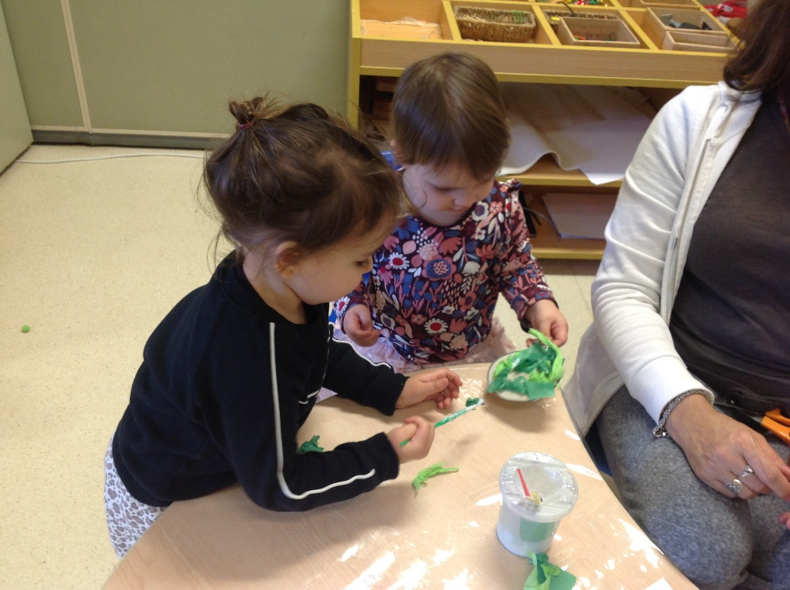

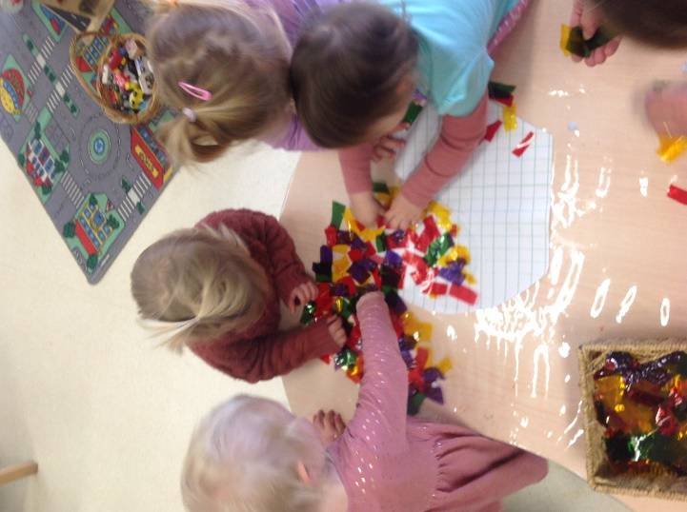

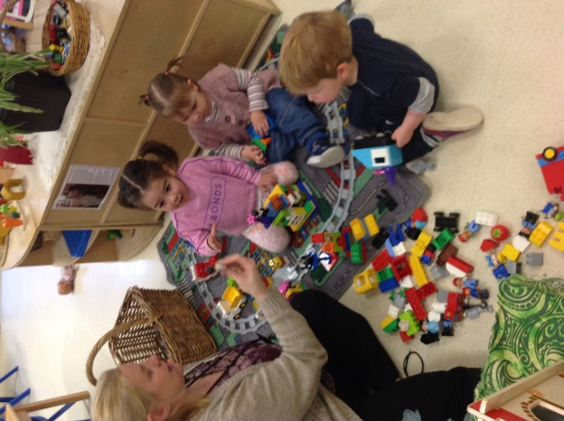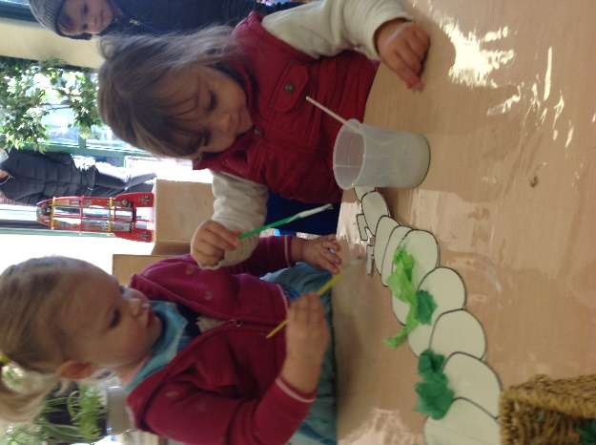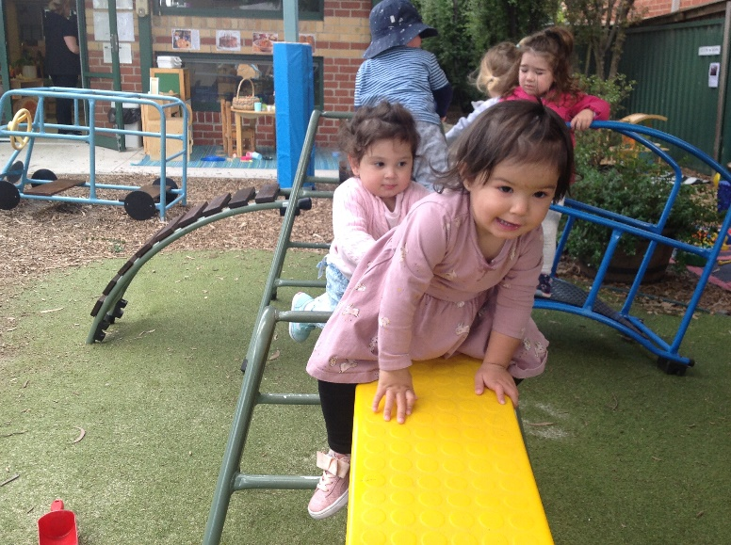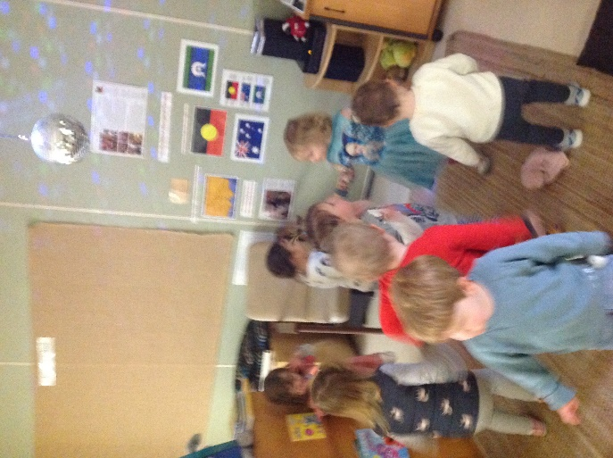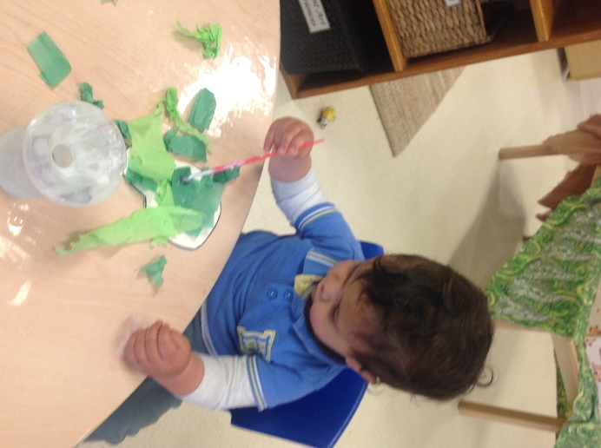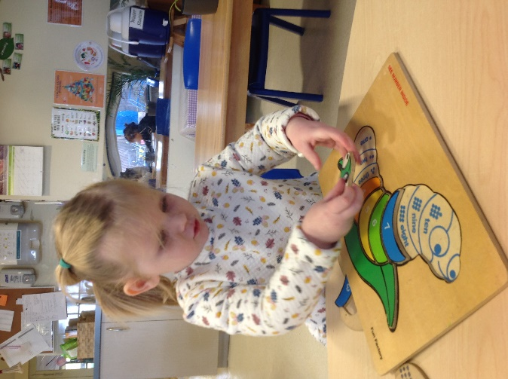

***Links to the National Quality Standards: Quality Area 1, Educational Program and Practice and Quality Area 1 Program and Practice and TRCC Philosophy***