

**Families and Children**

Welcome to March and the first days of Autumn, goodbye Summer, oh what was that? Where did Summer go? Did we have Summer?

**The Range Children’s Centre Newsletter March / April 2020**

**Coronavirus**

**Update:** Some families have asked us what are we doing about the virus? Our response is this. We are guided by WHO (World Health Organisation) The Health Department and The Department of Education and Training. At the moment all we need to do is: if any one is feeling unwell and showing symptoms of the virus refer them to their doctor.

Continue to follow good hygiene practices. Cough and sneeze into your elbow and wash hands frequently. Educators are ensuring children are following these procedures as well.

**Staff Update**

**The Committee of Management consists of:**

**President:** Geoff

**Vice President:** Aislinn

**Secretary:** Carey

**Treasurer:** Rebecca

**General Member:** Kirsten, Shaun, Anna, Alistair, Aislinn, Jacqui, Jarrod, Jessica

**Kindergarten Constative Rep**: Kelly

You can contact the committee via email. [Committee@therangecc.org.au](mailto:Committee@therangecc.org.au)

If you would like to join the committee please pop in to the office and speak to Janice

**Management consists of:**

**Director:** Janice

**Assistant Director:** Nellie

**Educational Leader/ 3IC:** Robyn

**Bookkeeper:** Thao

Tuesday 8.30 – 5.00

Thursday 8.30 – 5.00

Friday 7.30-4.00

Friday 7.30 – 4.00

**Fee Statements**

Your fee statements will be emailed to you every 2 weeks. Families experiencing difficulties paying their fees should come and speak to Janice.

**2020 Fees**

Our long day care fees are $117 per day

**Kinder Term Fees.**

3-year-old kinder is $500

4-year-old kinder is $460

**Buying and Selling Days**

If you are wanting to buy or sell a day please notify Nellie in the office via email as soon as possible so that the day can be offered to someone who has requested it.

[nellie@therangecc.org.au](mailto:nellie@therangecc.org.au)

 Please visit our website to find out more information about our service and to access online forms

<https://www.therangecc.org.au/>

**Late Collection Policy**

The centre closes at 6pm. This means that you must have LEFT the centre by 6pm. For every 5 minutes after 6pm that a child is here a late fee will be imposed. The late fee currently stands at $10 for the first 5 minutes (or part thereof) and $15 for every 5 minutes thereafter. If a family is late 3 or more times within a 3-month period the third and subsequent fines will be doubled. Parents should phone the centre if they are going to be late as it can be distressing for a child to be left waiting alone and courteous to staff. On collection of your child, parents are required to sign the late book and the imposed fee will be added to the next fee statement. Late fees will be issued by the Director and are payable within 14 days.

**Immunisation Schedule**

Families are required to provide a copy of up to date (most recent) immunisations. If you bring it in we can copy it for you or you can email the document to the centre

You can obtain this from your MyGov account.

it is very important that our records are kept up to date as *No Jab No Play* rules apply

**From the educational leader**

Dear Families in case you are not aware of where things are located, here is a reminder:

* Parent Pockets are located on the wall outside your child’s room. For families that have more than one child attending the pockets are combined and under the oldest sibling’s name and room.
* Staff shifts are near the doors of each room
* Inside your child’s room you will find an A3 document displayed on a wall, this is the Educational Program for that room. Please feel free to take the time to have a read and you are welcome to discuss this with the educators
* Also within your child’s room, usually located where you sign your child in you will find a Parent Communication book. In this book you can leave messages for the staff in regards to your child. If it is of a personal mater please speak directly to an educator

**Children’s Portfolios**

Each child has their own individual portfolio. On a regular basis educator document your child’s learning journey and store it in these portfolios, along with some examples of their creativity and milestones. Families are welcome to take these portfolios home to show other family members and friends, however they are a work in progress and need to be signed out and in when they are returned. We welcome feedback from families about these portfolios. At the end of the year you get to keep these portfolios as a memento of your child’s year. **Centre Project**

As our wonderful service has achieved an Exceeding rating for the past two assessments, we are interested in undertaking a project that the whole centre can contribute to and benefit from. We have undertaken some training with our consultant Catherine Hydon and with all educators and the popular consensus is that we can all benefit from learning about our own and others wellbeing, therefore we will be undertaking a “Project “that will include all ages and all abilities. Our aim is to teach the children how to recognise their emotions, how they can regulate their reactions to these emotions and identify the triggers. Along the way we will also be working with families so we are all working towards the same outcome

Please watch this space for updates and ways you can contribute

**Head Lice**

Now is the time that some children may get Head Lice. While this is not a medical condition it can spread very easily and makes children uncomfortable. Our procedures for managing Head Lice are:

***Parents will be notified when collecting their child. Parents will be advised that their child can return the next day provided effective treatment is commenced prior to the next day***

***Provide information on head lice, treatment and control to the family***

***Display signage that head lice may be present at the Centre while maintaining confidentiality.***

**Head Lice Treatment Using White Conditioner**

Apply hair conditioner to dry hair (white conditioner makes it easier to see the eggs). Use enough conditioner to cover the whole scalp and all the hair from roots to tips.  
Use an ordinary comb to evenly distribute the conditioner, and divide the hair into four or more sections using hair clips.  
Starting with a section at the back of the head, place the teeth of a head lice comb ﬂat against the scalp. Comb the hair from the roots through to the tips.  
 Wipe the comb clean on a tissue after each stroke and check for head lice or eggs on the tissue.  
Comb each section twice until you have combed the whole head. If the comb becomes clogged, use an old toothbrush, dental ﬂoss or a safety pin to remove the head lice or eggs.  
The conditioner and combing technique is also an effective head lice treatment. Keep combing the whole head until all the conditioner is gone. Repeat the process daily until no lice or eggs have been found for 10 days.  
Chemical treatments are also available for head lice—your pharmacist can help you choose a product.

**Centre Policies**

The centre policies are located in the office. If you’re wanting to view them please feel free to ask the office staff.

Our centre Philosophy is displayed in the foyer. Our Centre Philosophy will be up for review very soon, if you have any thoughts or suggestions please email the office. Watch this space for more details on how you can be involved in the review

**Grants**

We have recently applied for two grants. One is from Hobsons Bay. This is to support our Whole Centre Wellness Project

The other is from The Bendigo Community Bank to obtain funding to purchase a Defibrillator

We will keep you informed of our progress.

**Kinder Groups and Times:**

4 yr old Green group: Tuesday and Thursday 8:30am – 4:30pm

4 yr old Yellow group: Wednesday and Friday 8:30am – 4:30pm

3 yr old Orange group: Monday 9:30am – 4pm

**Kindergarten Term Dates**

1st term: Tuesday 28th January – Friday 27th March

2nd term: Tuesday 14th April – Friday 26th June

3rd term: Monday 13th July – Friday 18th September

4th term: Monday 5th October – Friday 18th December

**Hobsons Bay Immunisation Program 2020**

<https://www.hobsonsbay.vic.gov.au/Community/Community-services/Families-Children/Immunisation>

**Emergency Evacuation Procedure**

Every month an allocated room will call a drill within the centre. These drills may be a fire drill, a lock down or a shelter in place. These drills allow children and staff to be prepared and aware of procedures if at any time a real emergency may occur. When we have a drill, we evacuate to our pre-determined meeting points either in the koala/kookaburra yard by the amphitheatre or in the fairy garden/entry area. These are drill meeting points only. In case of a real event we would evacuate to corner of the carpark, opposite the entry gate. If we need to evacuate offsite, we then proceed to our secondary safety assembly point. This is located next door at Nelson Bros funeral home.

With the recent Air Quality dangers, we follow the actions for a lock down, which is practiced during our drills. We have apps which allow us to monitor air quality along with our SunSmart app which indicates the UV levels and times when sun protection is recommended

As required under the National Regulations we have and Emergency Management Plan in place. This plan outlines procedures and actions to be followed in an emergency. If you're interested in reading our Emergency Management Plan it is located in the foyer opposite the office on the notice board. Alternatively, please feel free to have a chat to the staff.

**Signing in and out**

Just a reminder that parents / guardians are

required to sign their child in and out of the

centre on the iPad each day. Children can be signed in or out on any iPad, however please let your child’s teacher know if you have signed your child out in another room. This is a legal requirement and this enables educators to monitor which

children are present or absent. If you experience any difficulty with the iPad please speak to an educator who can assist you.

**Car Park Safety**

Just a reminder to all families that the car park has a speed limit of **5 kms.**

Please be careful when entering and exiting the car park as children sometimes detach themselves from their parents and can run off. Also please keep an eye out for pedestrians on the foot path.

**Parent Representative**

All families will have received information about Volunteer Parent Representatives. We would like to thank the parents that have volunteered. We are still in need of representatives for the Kookaburras Room and Orange and Yellow Kinder Groups. If you are able to volunteer for this project please let Janice or Nellie know.



**Yard Maintenance**

After some negotiation Hobsons Bay have agreed to restoring the outdoor equipment. This is the fixed wooden structures. They will receive a sand back and re staining to give them a fresh new look. This work should be completed during the next term break

**10 Years Of service**

Congratulations to these employees for their 10 years of service: We thank you for all of your hard work and dedication

**Robyn, Janice, Jenny, Lena**

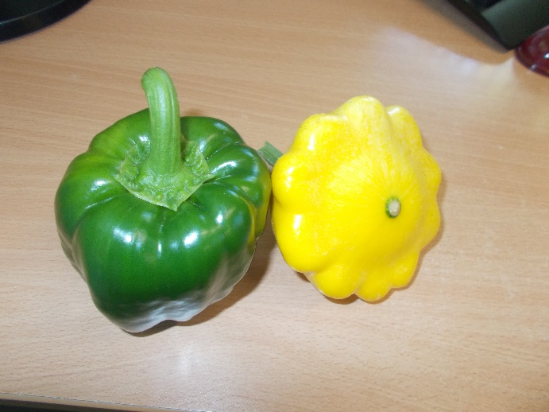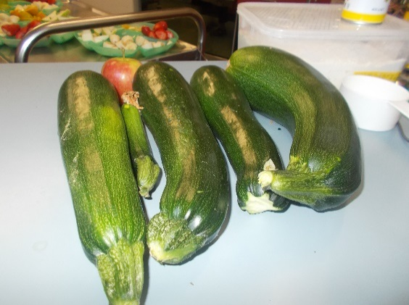

**Sustainability**

Many of you may know that over the Christmas period Christmas trees are sold from our carpark. We receive a % of the sales. The money from this has been used to build, install and prepare two new garden beds for our community garden in the car park. These are the huge organic zucchinis and perfect capsicum and squash we have harvested in the last few days; they will be used by the kitchen to make veggie patties.

We would like to say a big thank you to Warwick for coming in and tidying up the Fairy garden and the garden around the car park

**Feedback**

We welcome feedback! If you have something you would like to tell us please feel free to drop us a line. You can email us on [office@therangecc.org.au](mailto:office@therangecc.org.au) or you can write us a note and drop it in the feedback box located in the foyer. It can be anonymous if you prefer. We would like to thank the families that gave us feedback about our Christmas Concert. This information is useful in helping us to improve our service to you

**Training**

There is a lot of staff training happening over the next few months;

Nicole has recently visit Canberra to learn more about the ELSA project, which teaches children about STEM using apps on the iPad.

First aid and CPR have taken place and in April staff will be undertaking Asthma training

Nanisi has taken on the Let’s Count Learning through the Smith Family. This course teaches educators how to include maths concepts into the program. Some families have been asked to take part and Nanisi will share her learning with her co-educators as she progresses

All educators are undertaking the Mandatory Reporting e Module for child protection

**Important Dates**

**Monday 9th March Centre Closed** Labour Day

**Friday 10th April Centre Closed** Good Friday

**Monday 13th April Centre Closed** Easter Monday

**Dates for Your Diary**

**Term 1**

* African Drumming
* Team Bubbly
* Dinosaurs Fossils
* Dental Visit

**Term 2**

* Animals on the Move
* The Flying Book Worm

**Term 3**

* Traffic School
* Mr Ants Great Recycling Adventure

**Term 4**

* Wild Action

**Centre Photos**

* Hello Photos 5th October

**Dates and groups will be advised at a later date**



**Vegetarian Patties**

(Best made the day before)

5 kgs potato

5 carrots grated

5 zucchinis grated

2 onions chopped

3 tablespoons (Massel brand) vegetable stock powder

bread crumbs

peel potatoes and cook until soft. Drain and mash. Mix grated vegies into potato

add onions and vegetable stock powder

**Next Day**

Add some bread crumbs.

Roll into small balls and shallow fry in oil

***Links to the National Quality Standards: Quality Area 6 Collaborative Partnerships with Families and Communities***