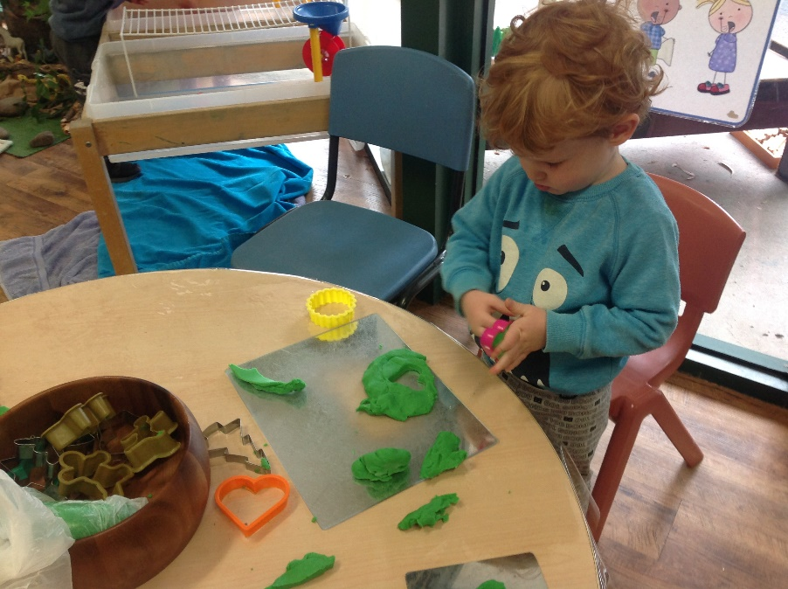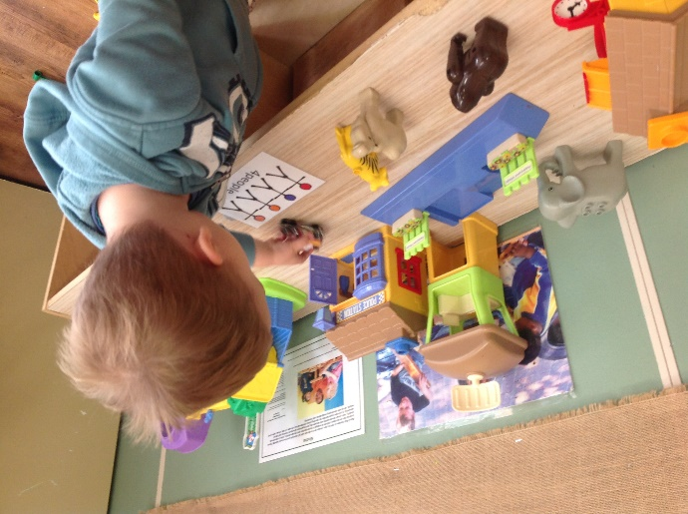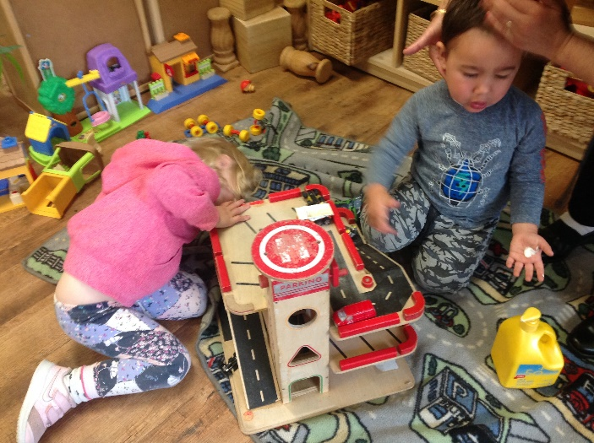Reflection 1, January 2020, Koala Room

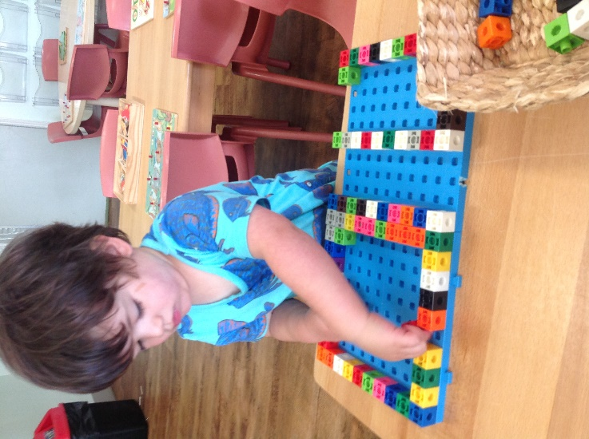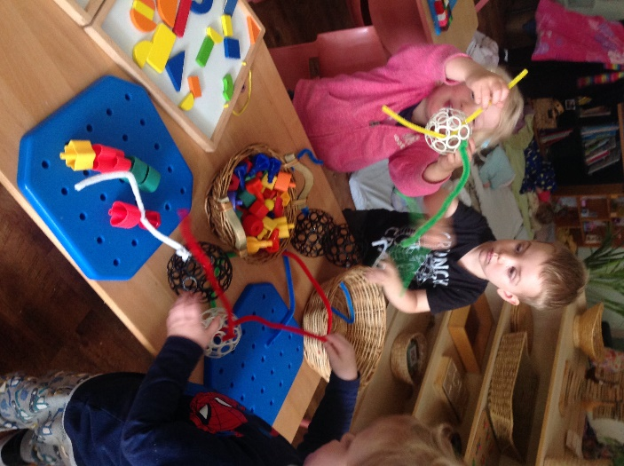

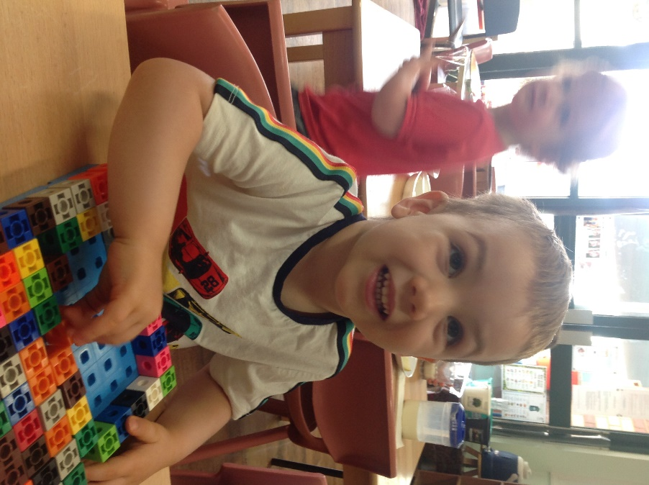

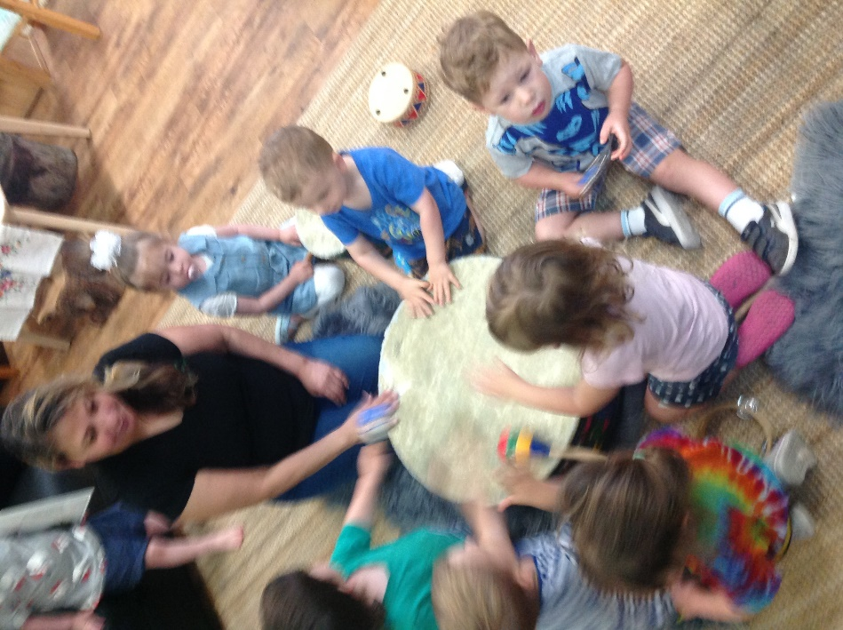

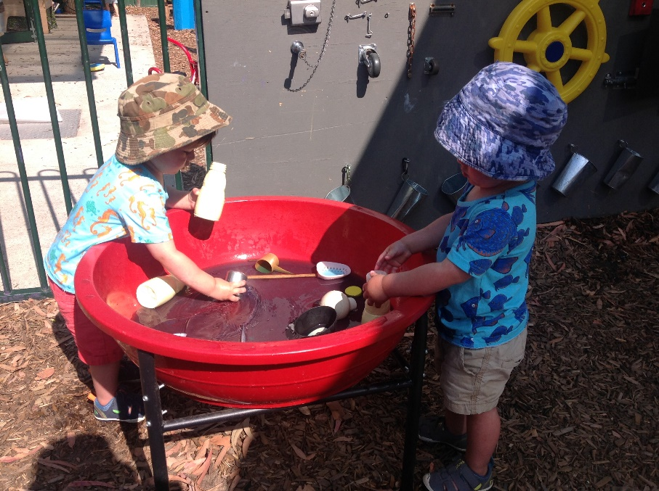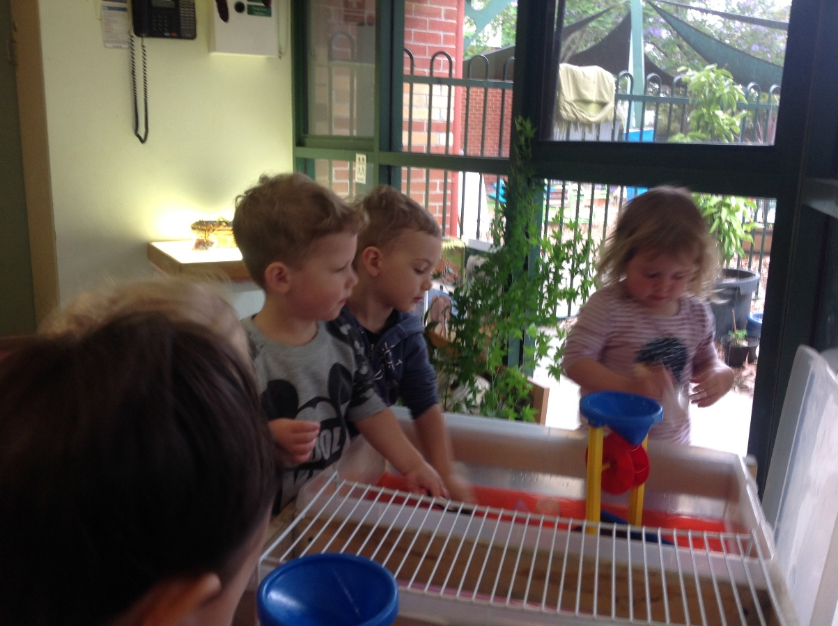

Welcome Koala families. Wow we are off to a flying start for 2020. The children are enjoying some challenging activities throughout the indoor and outdoor learning spaces. Lots of fine motor, gross motor, manipulative tasks adorn the Koala’s indoor and outdoor areas this month. Pre mathematics and early literacy are our major focus for the year as well as language and social skills. This year brings many opportunities to further develop all the pre-school skills. The children are all very pleased to see each other and have been very busy researching the room and spaces finding areas that interest them and test their skills and abilities, finding new challenges and exploring their new environment.

National Quality Standards. QA1. Educational program and Practice and TRCC Philosophy.

National Quality Standards. QA1. Educational program and Practice and TRCC Philosophy.