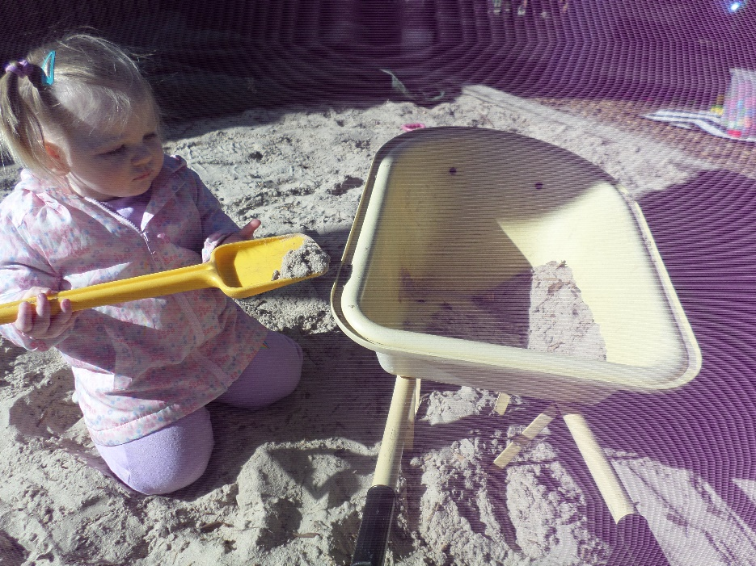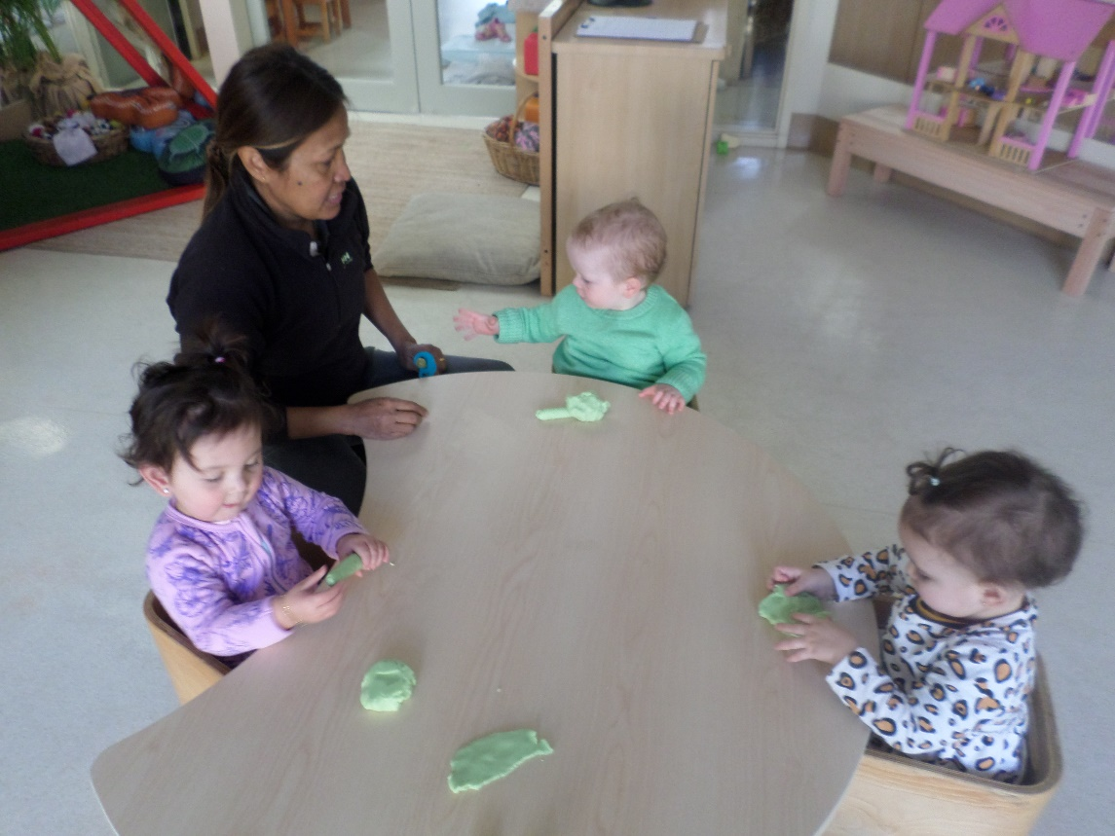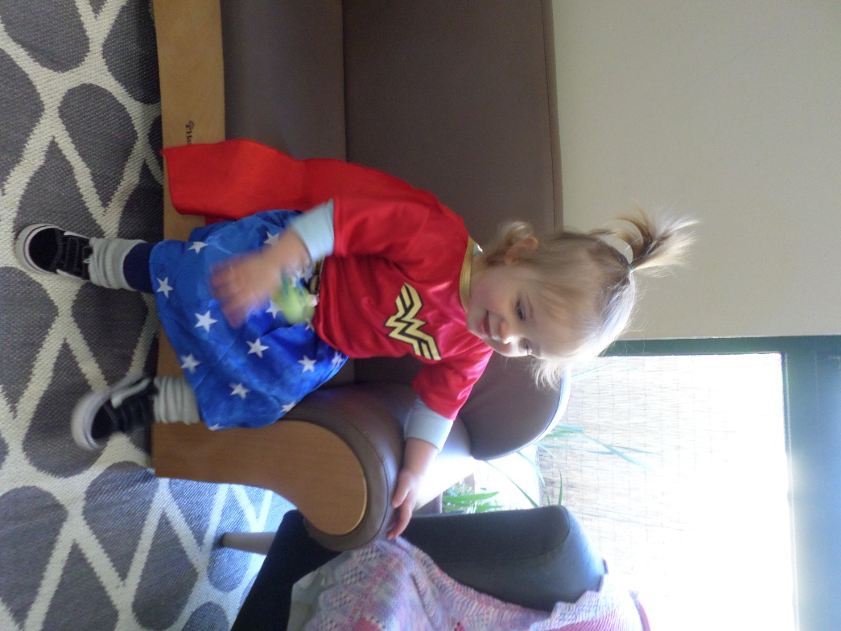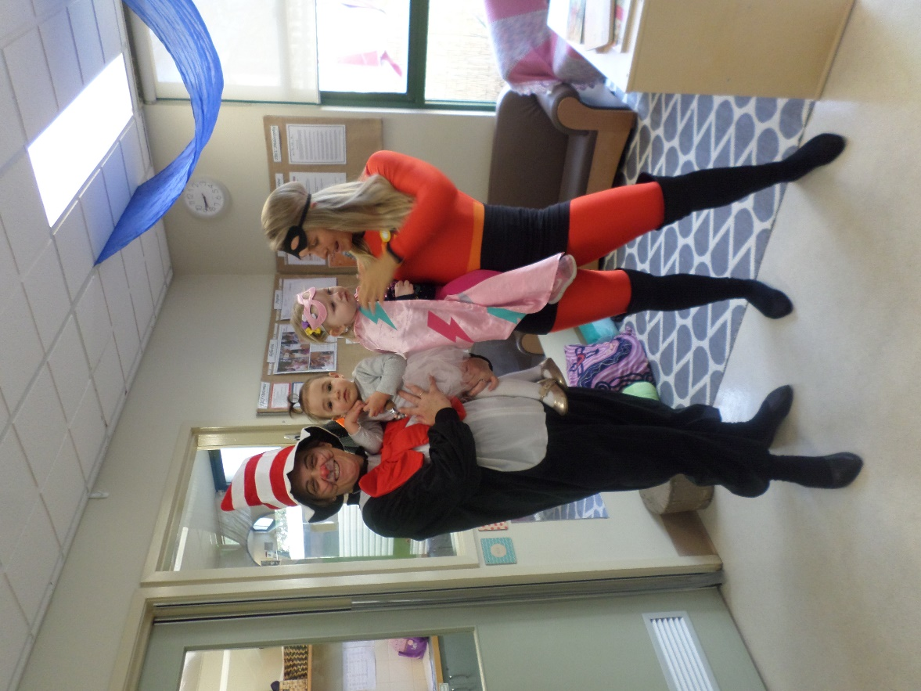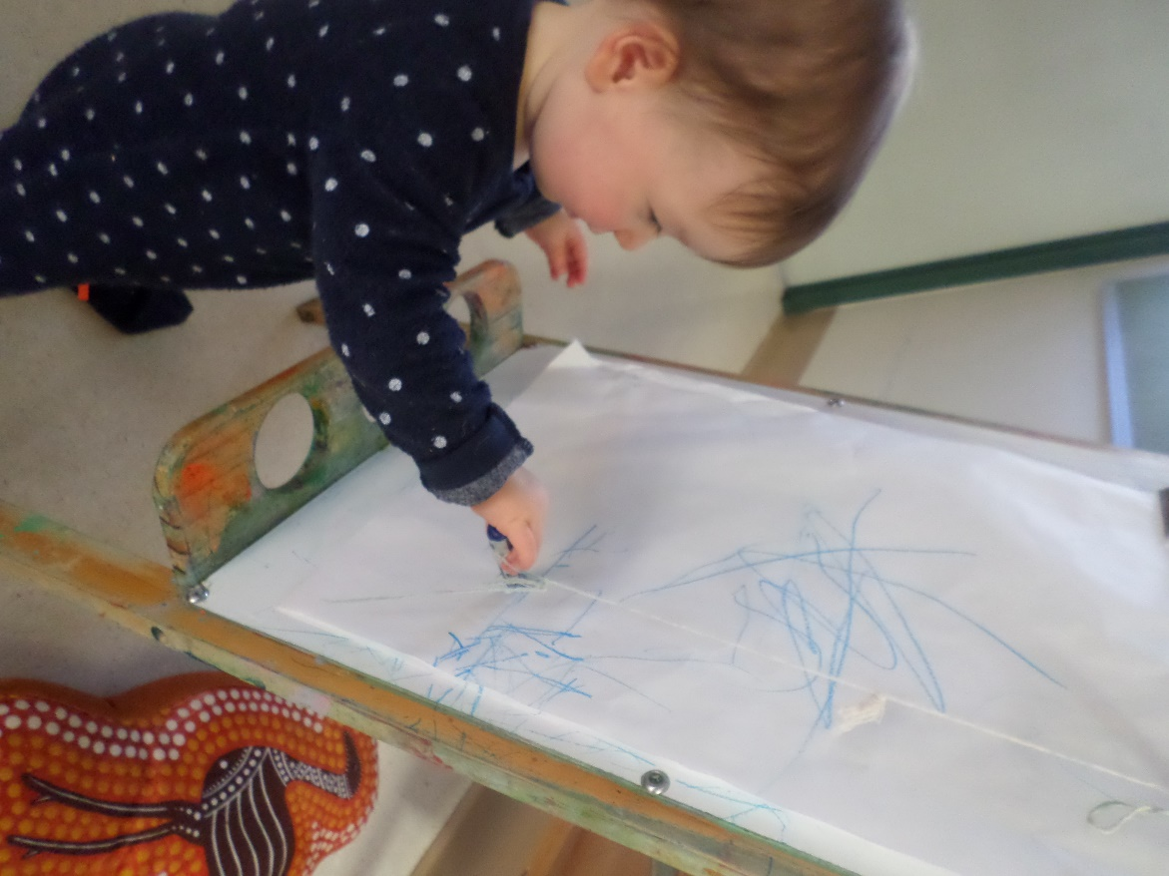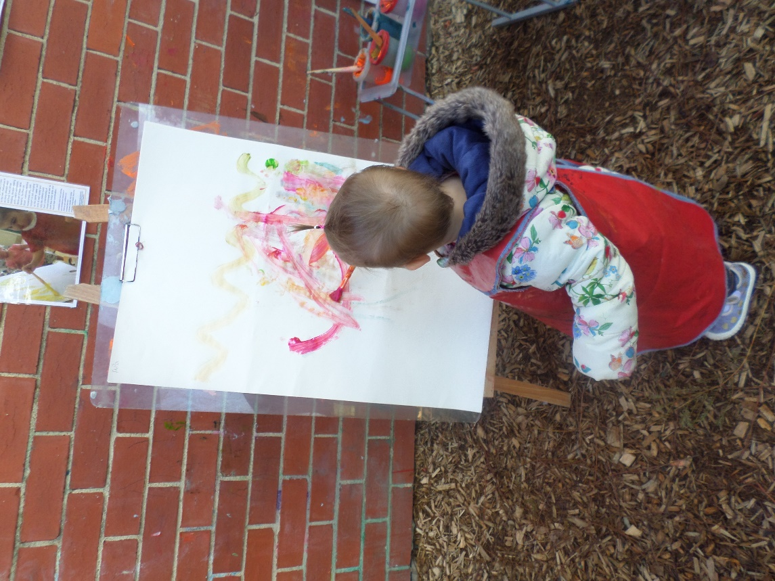**August Reflection 2**

The month of August has seen the children being involved in different art experiences. When we go outside the children have the opportunity to paint at the easel using a variety of colours. Often you will se some of the children going over to the area and waiting for their turn. In the room we have set up an easel with paper and a crayon for the children to continue to increase their fine motor and eye and hand co-ordination to hold and move the crayon across the paper to make marks and lines. We have also introduced playdough in the afternoon for the children to have and activity to sit down and relax with after having a play outside. In August we celebrated book week where we read a lot of books throughout the week to the children,

e had a dress up day for everyone to come dressed as a book character or a super hero. It was great to see some of the Joey children dressed up for the day. With the sunny days approaching and more of the children having one sleep we are starting to go outside for longer periods in the morning and afternoons. The children love to explore their spaces moving in the sandpit to climbing on the frames and painting at the easel.